Report Title: Report Traffic Light Control System Unit Code - EMT 3104: Mechatronic Systems Programming I Student Number: E022-01-0794/2019 Student Name: Njeri Newton Kariuki Submission Data: 27th May 2021

Table of Contents
Chapter 1: Introduction 3
Chapter 2: Methodology 3
Circuit Diagram 3
System Implementation 3
Components and functionality 4
Code Flowchart 4
Code Implementation 5
Chapter 3: Discussion 5
Chapter 4: Conclusion 6
References 7

Chapter 1: Introduction
Traffic Light Systems are mostly applied in busy street roads to help avoid accidents and ensure smooth flow of traffic in the road. They consist of three lights each conveying a specific message to the users of the road. By convention the three colors are Red, Orange (amber), and Green, and they appear in this order on a vertical column. These lights follow a specific sequence, beginning with red light, it lights for some time requiring all the vehicles to stop and allow pedestrians to cross the road. After some time the amber lights together with the red light, the amber stands “for ready”. After lighting for some time both amber and red are set off, and the green light lights allowing the vehicles to move.
From the working of a Traffic Light Control System, in this project a simpler version of the system was developed. The project was done with help of Micro Chip Studio and a simulation environment, in this case Proteus Software. Micro Chip Studio was used to write the program.

Chapter 2: Methodology

Circuit Diagram
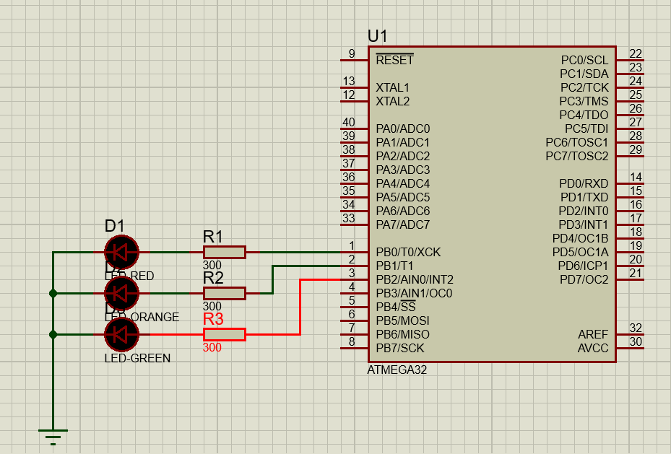
Figure 1: Circuit Diagram Of A Simple Traffic Light Control System

System Implementation
A program for the time based traffic light control system was written guided by the flowchart using microchip studio. The circuit in figure 1, was then developed in Proteus. The value of the resistor used for each LED was determined by use of the formula below:
𝑅 = (𝑉𝑜𝑙𝑡𝑎𝑔𝑒 𝑆𝑢𝑝𝑝𝑙𝑖𝑒𝑑 − 𝐹𝑜𝑟𝑤𝑎𝑟𝑑 𝑉𝑜𝑙𝑡𝑎𝑔𝑒) / (𝐶𝑢𝑟𝑟𝑒𝑛𝑡 𝐹𝑙𝑜𝑤 𝑡ℎ𝑟𝑜𝑢𝑔ℎ 𝐿𝐸𝐷)
Voltage supplied = 5v
Forward voltage = 2.2v
Current flow through LED = 10mA
R = (5-2.2)v/0.01 = 280 ohms
Since 280 ohms resistors are not commercially available and are much of exact resistors of 300ohms were used.

Components and functionality
- Red LED (D1) – Represent the red light of the traffic light system
- Orange LED (D2) – Represent the orange (amber) light of the traffic light system
- Green LED (D3) – Represent the green light of the traffic light system
- Resistors (R1, R2, R3) – Protect LEDs D1, D2, D3 respectively from being damaged
- Atmega32 microcontroller – Used as an interface between the program and the hardware

Code Flowchart
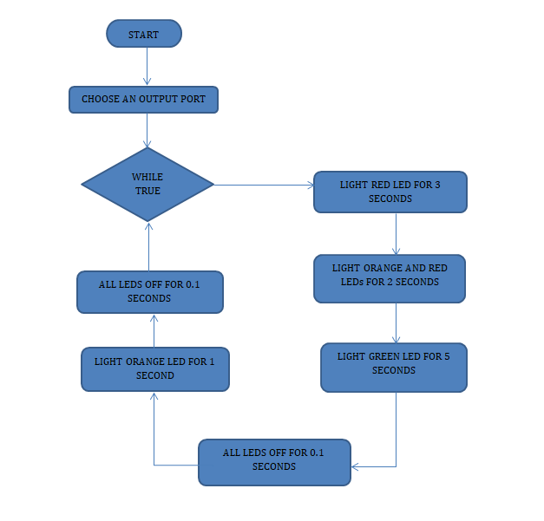

Code Implementation
/*
* Time Based Traffic Light system.cpp
*
* Created: 25/05/2021 15:47:00
* Author : newton
*/
#define F_CPU 8000000UL // definition for the clock speed that will be used for the micro controller
#include <avr/io.h> //header file for input and output
#include <util/delay.h> //header file for delay function

int main(void)
{
DDRB = 0x00; // Setting all pins in PortB as output
while (1)
{
PORTB = PORTB|(1<<PB0); /* making PB0 high lights red LED */
_delay_ms(3000);
PORTB = PORTB|(1<<PB1); /* making PB1 high lights orange LED */
_delay_ms(2000);
PORTB = ~PORTB|(1<<PB2); /* making PB2 high lights green LED */
_delay_ms(5000);
PORTB = 00;/* making all portB pins low, puts off all the LEDs */
_delay_ms(100);
PORTB = PORTB|(1<<PB1);/* making PB1 high lights orange LED */
_delay_ms(1000);
PORTB = 00;/* making all portB pins low, puts off all the LEDs */
_delay_ms(100);

}
}

Chapter 3: Discussion
The first line of the code defines the clock speed used for the micro controller; Atmega32. Header files for input output definitions are included together with the delay function header. In the main method all port b pins all made output by initializing DDRB to a hexadecimal value of 0xFF i.e. initializing all pins to HIGH. Within an infinite while loop pin 0 is set HIGH for three seconds, then pin 0 and pin 1 for 2 seconds, pin 2 for 5 seconds, all pins are then set LOW for 0.1 seconds, pin 1 is set on again for 0.1 seconds and finally all pins are set LOW. Since the code is within a loop it is executed repeatedly.
The simulation was done in Proteus, the circuit in figure 1 was developed and the “.hex” file uploaded into the atmega32 micro controller. In running the simulation, it was observed that the red LED lit for 3 seconds and then joined by the orange LED for 2 seconds. The green LED then lit for 5 seconds immediately both red and yellow LEDs went off. This was followed by a very short time of off state of the three LEDs, of 0.1 seconds as stipulated in the program. The orange LED then lit for 1 second and again a short time of off state of all the three LEDs (0.1 seconds) after which the sequence started again and the process continued until the stop button was pressed in Proteus.

Chapter 4: Conclusion
The project involved control of a simple time based traffic light system using atmega32 microcontroller. A program to control the switching on and off of specific LEDs was written and uploaded on the Atmega32 in the simulation software: Proteus. The involved circuit developed and then the simulation was performed.

References
- Wonderopolis (2021) How Does a Traffic Light Work : link https://wonderopolis.org/wonder/how-does-a-traffic-light-work
- Mr. Gichane (2019)Individual Project Report Template
- Elliot Williams. (2014).Make: AVR Programming. Maker Media, Inc.,

